Testing Documentation

1. Log into app as an admin

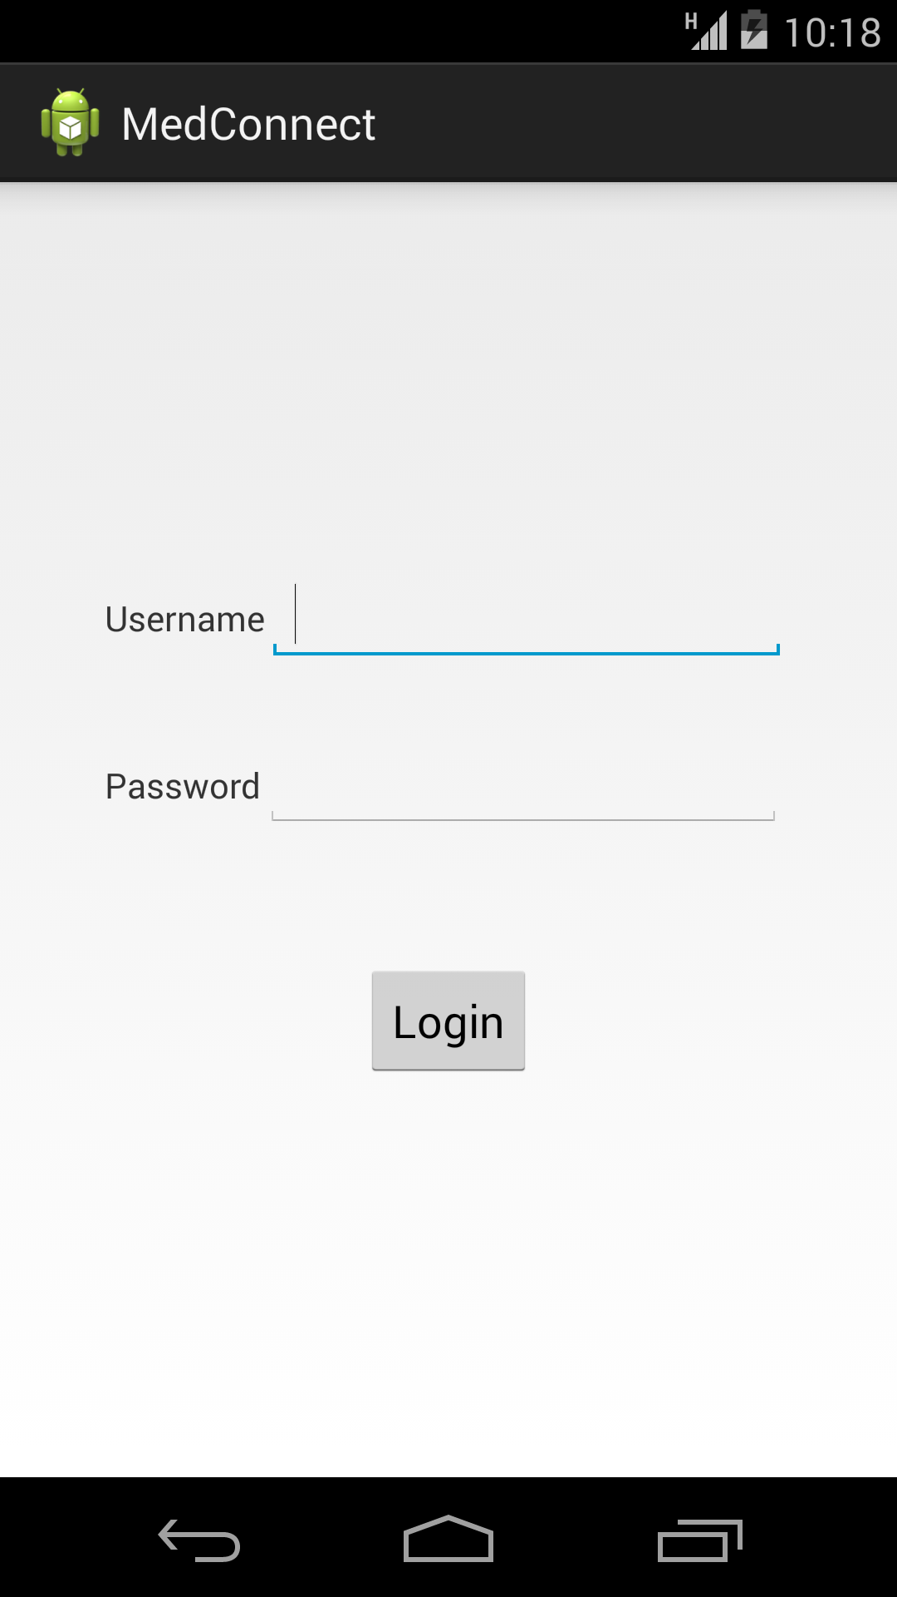

* 1. Navigate to doctors tab

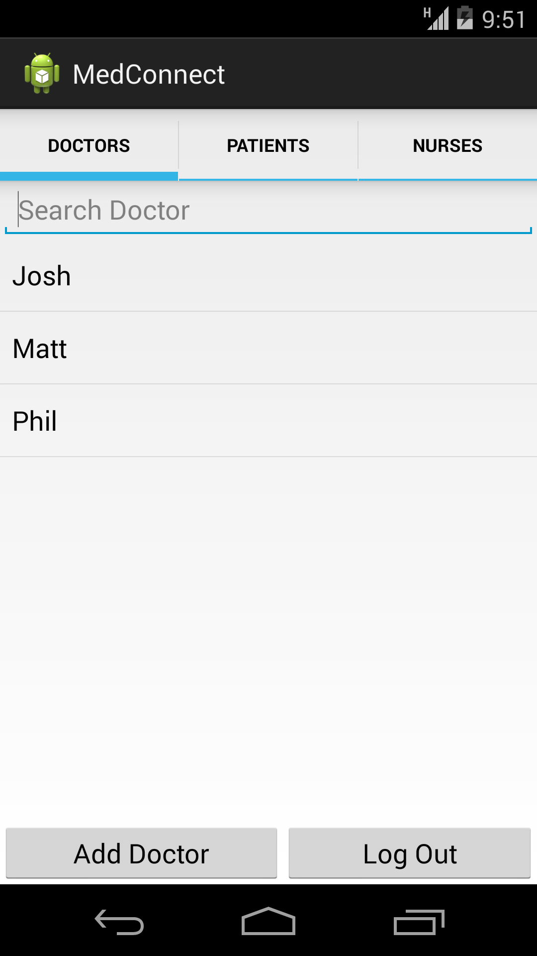

* 1. Create a doctor user

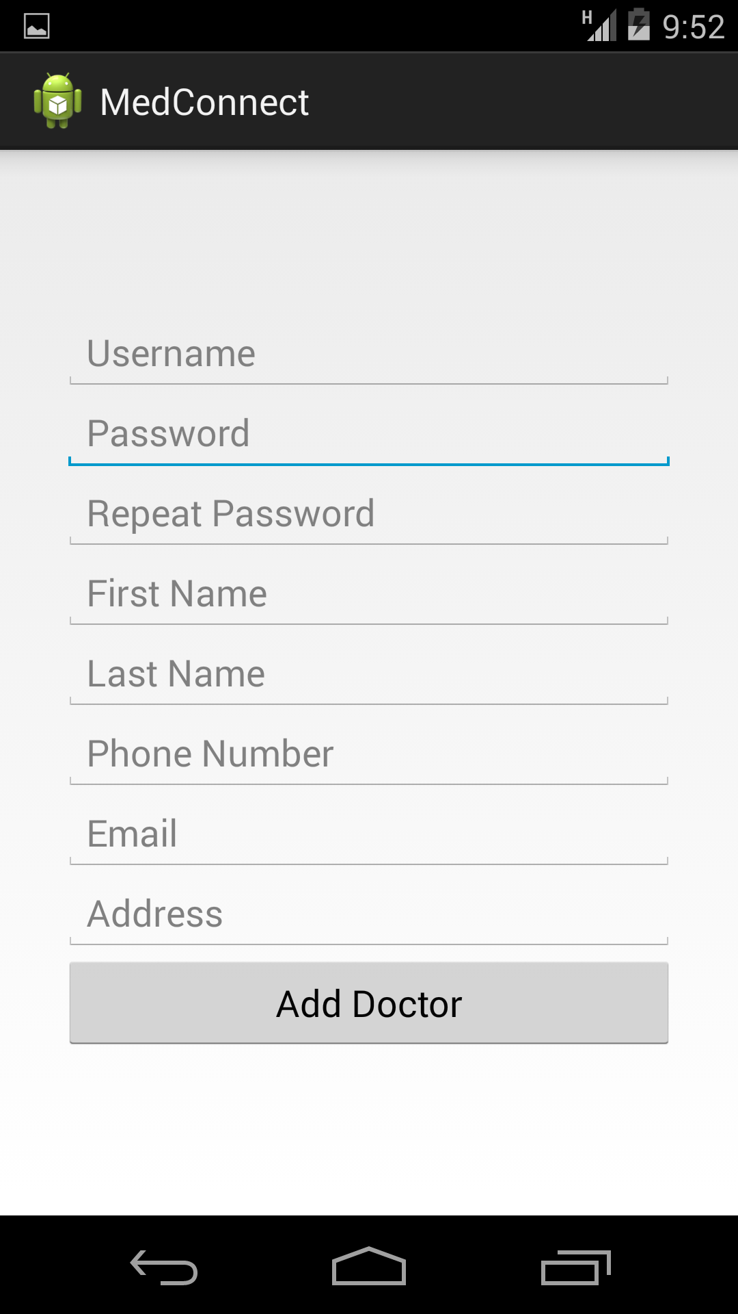

* 1. Navigate to nurse tab

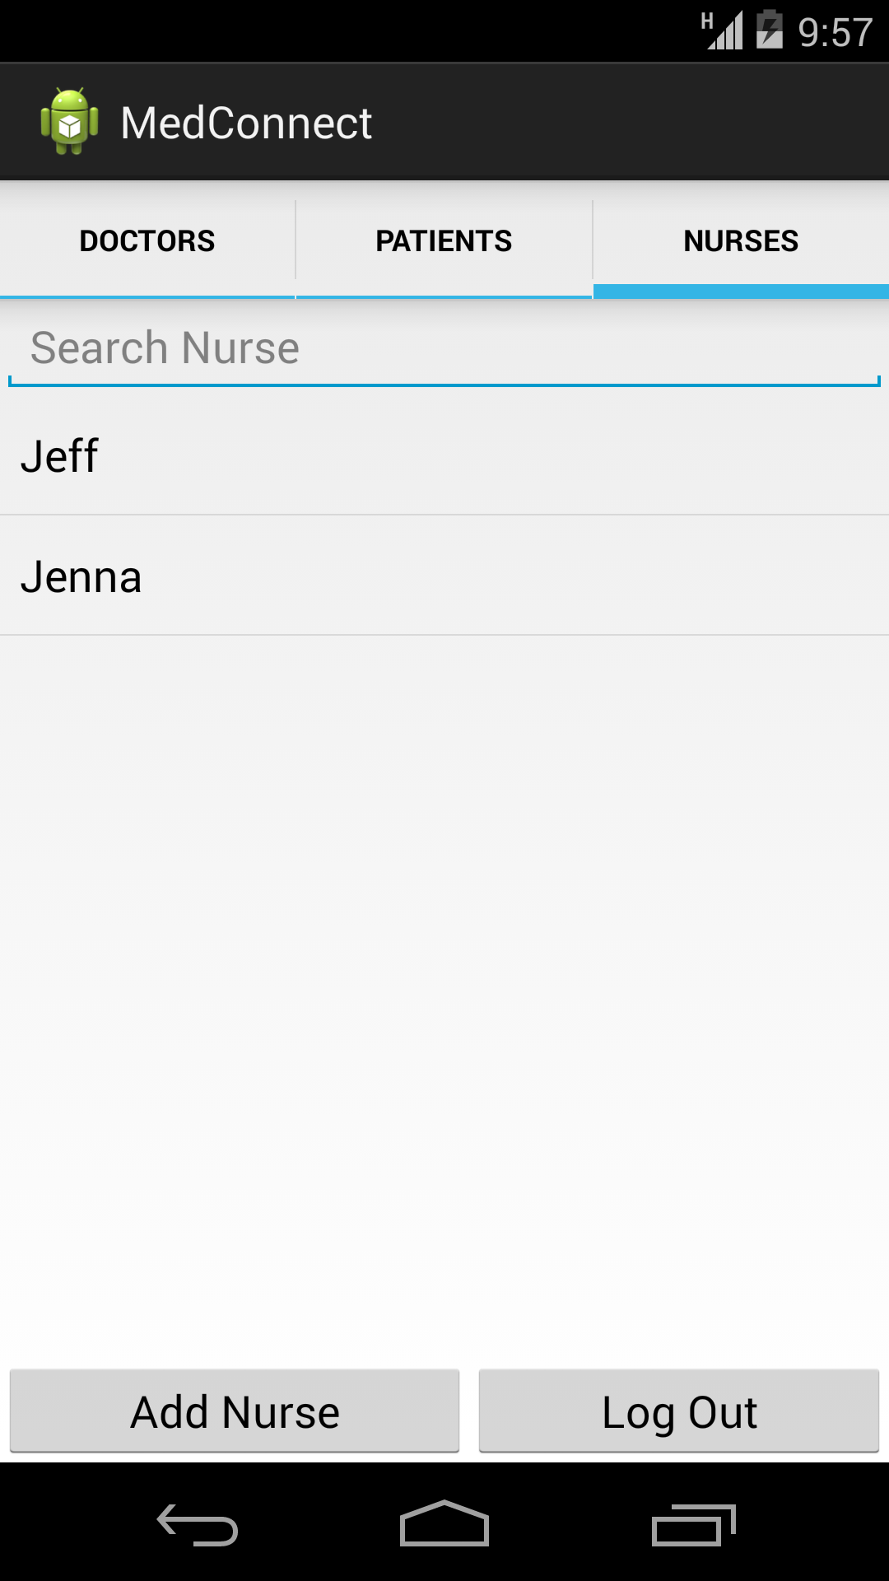

* 1. Create a nurse user

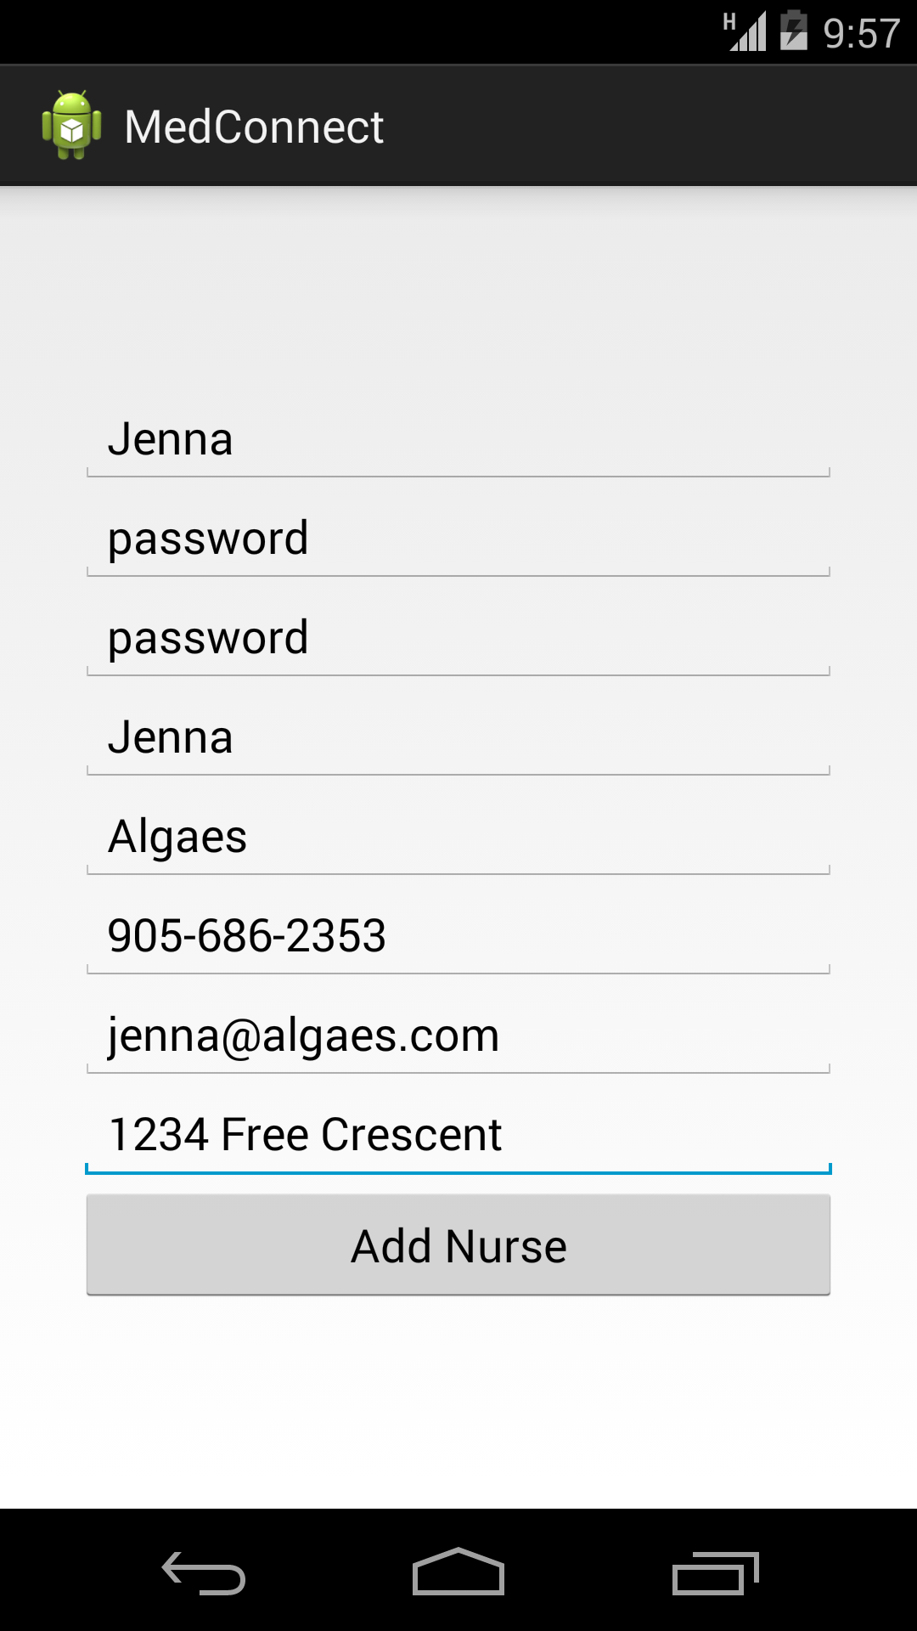

* 1. Navigate to patient tab

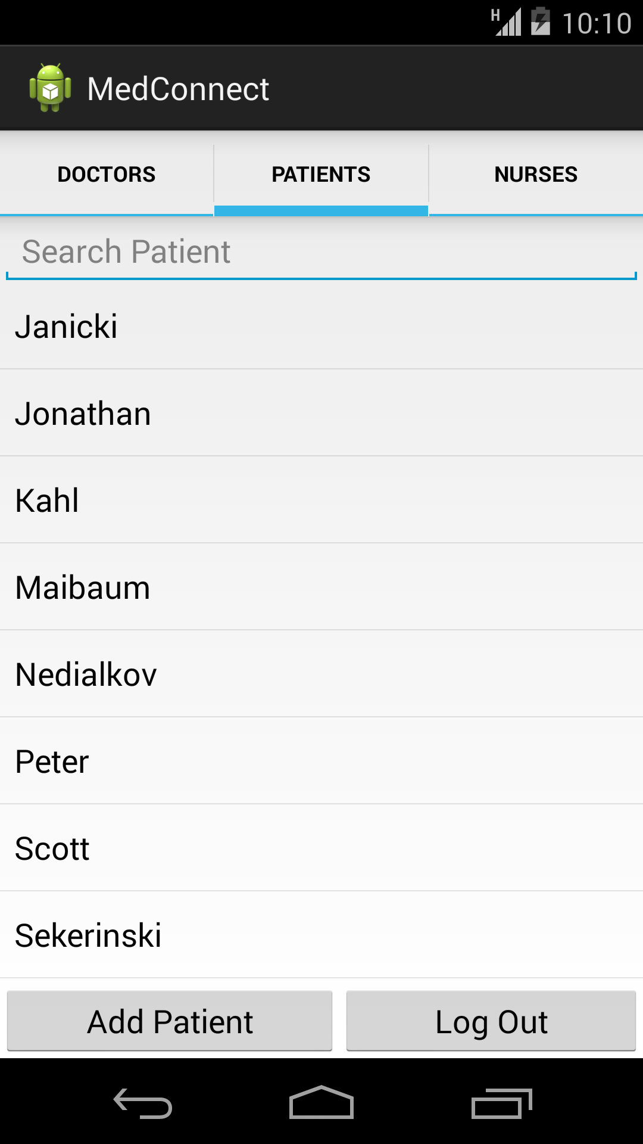

* 1. Create a patient user
     1. Assign patient to one of the created doctors

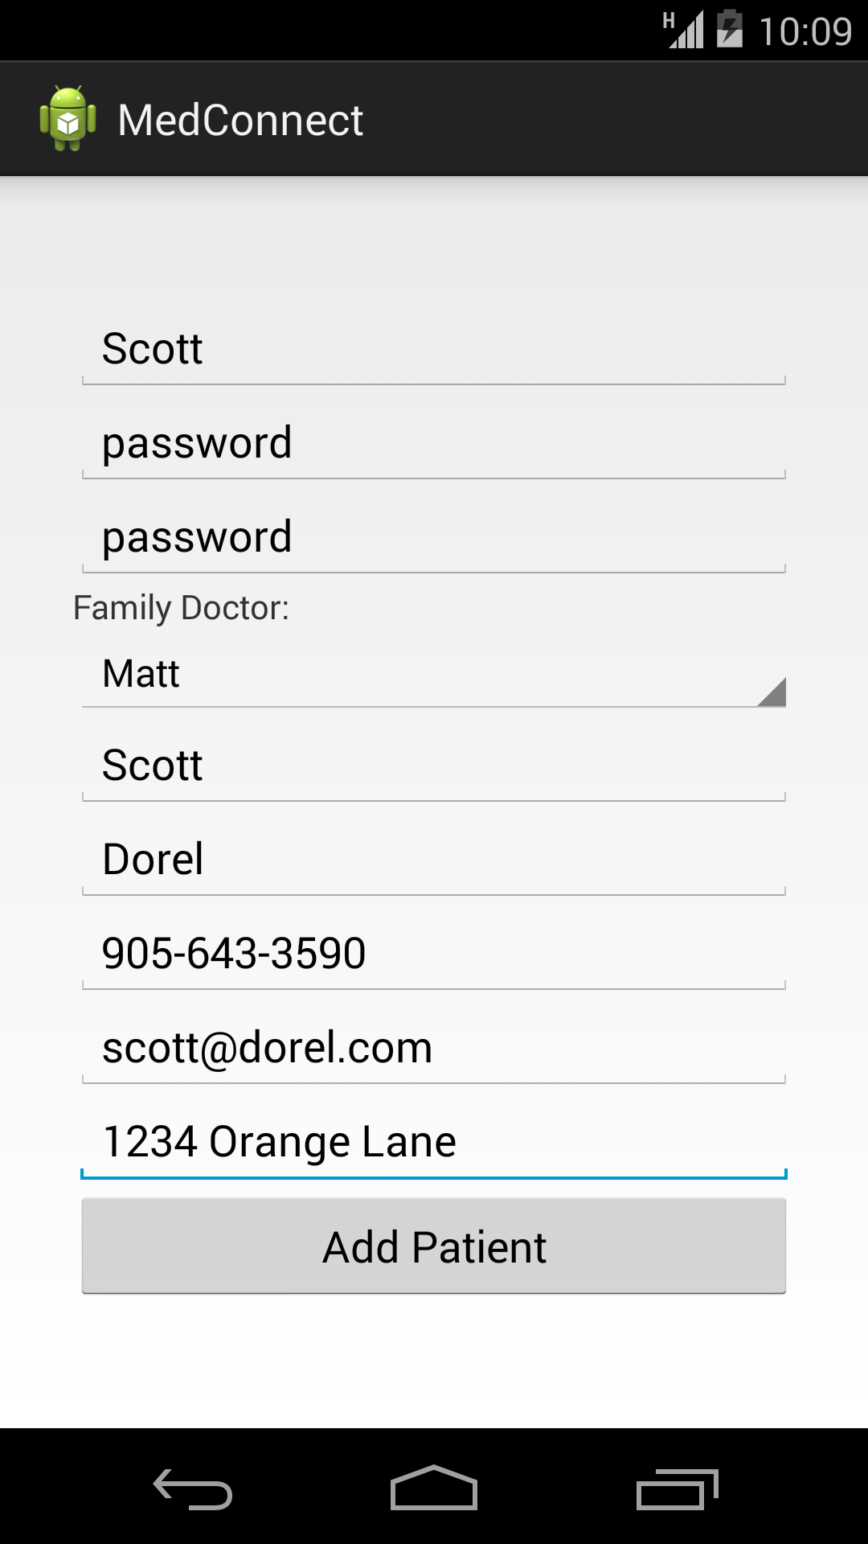

* 1. Log out of app

1. Log into app as a doctor



* 1. Click on and view a patient
     1. Add information to patient

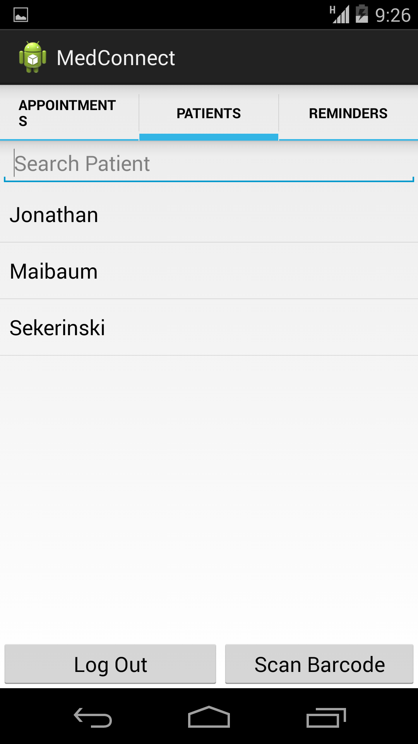

* + 1. Add a prescription to patient

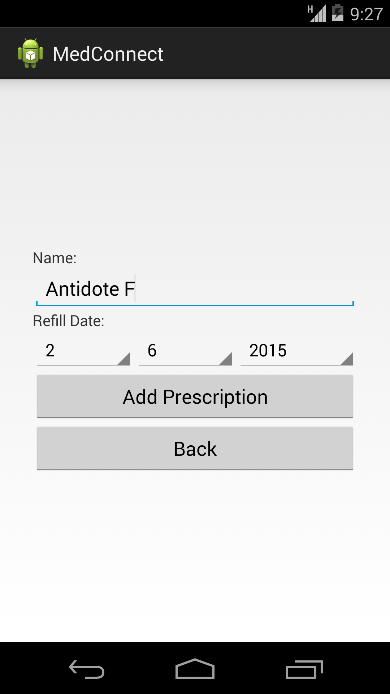

* 1. Navigate to patient graph and input a new BMI point

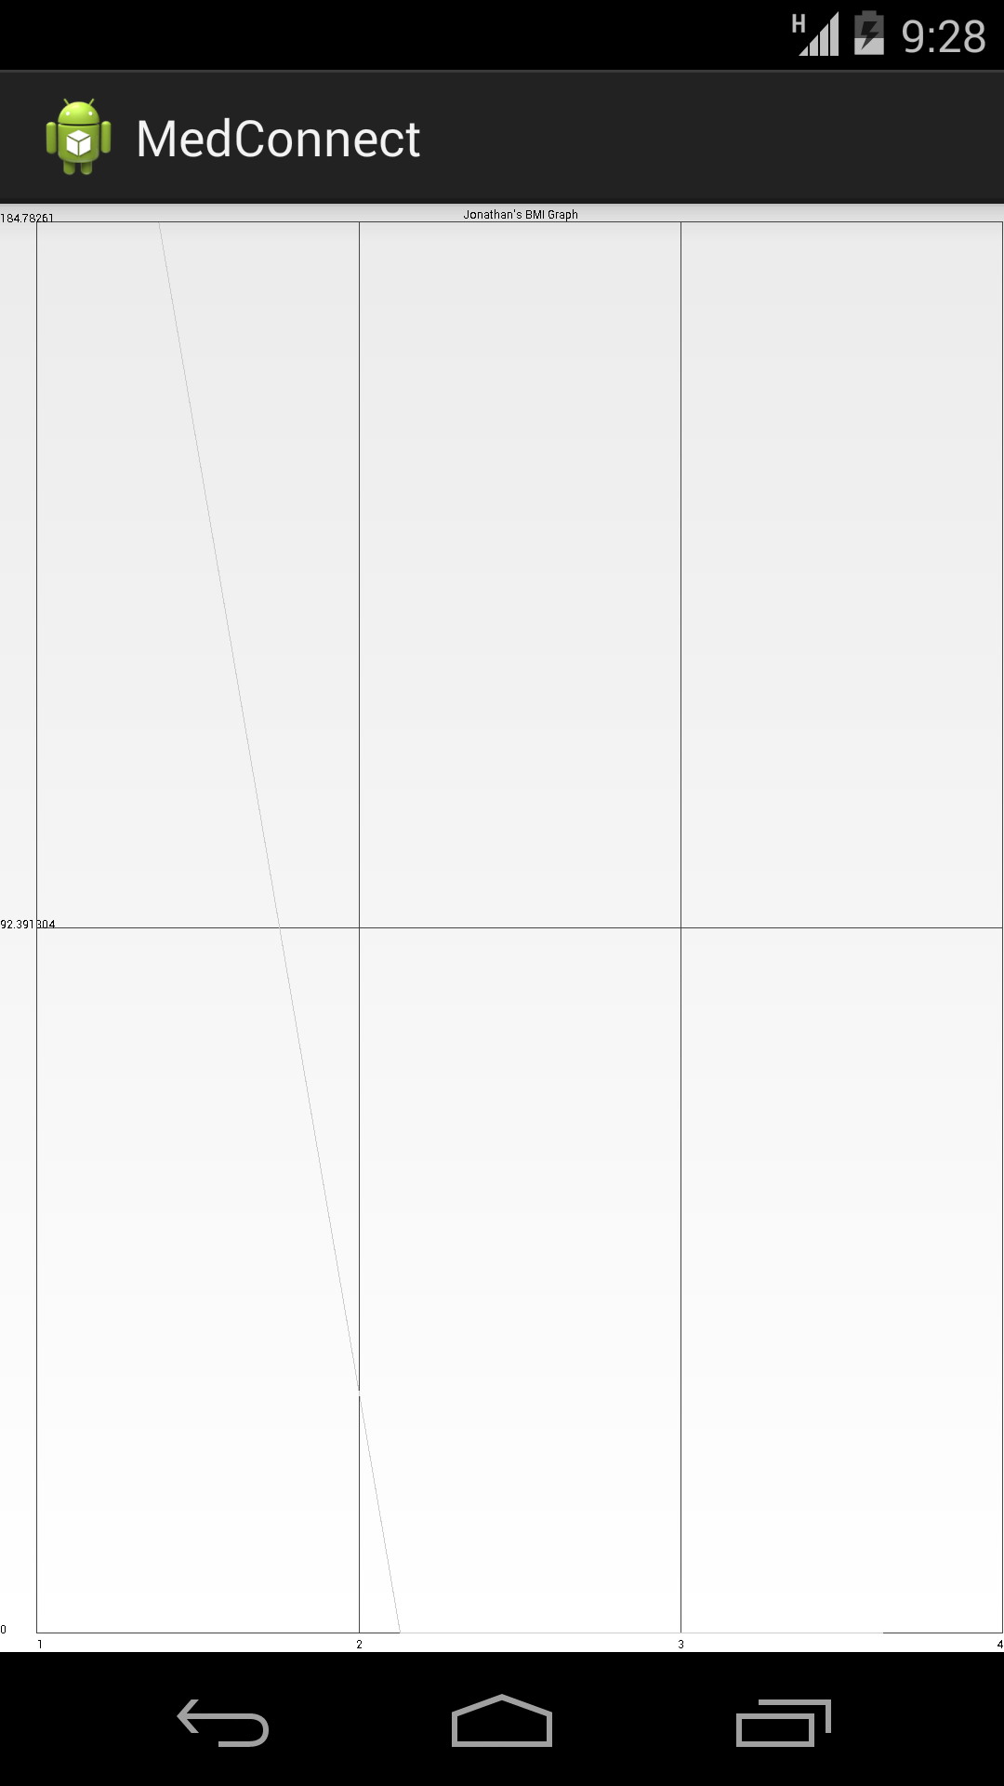

* 1. Navigate to reminders tab and view upcoming appointments

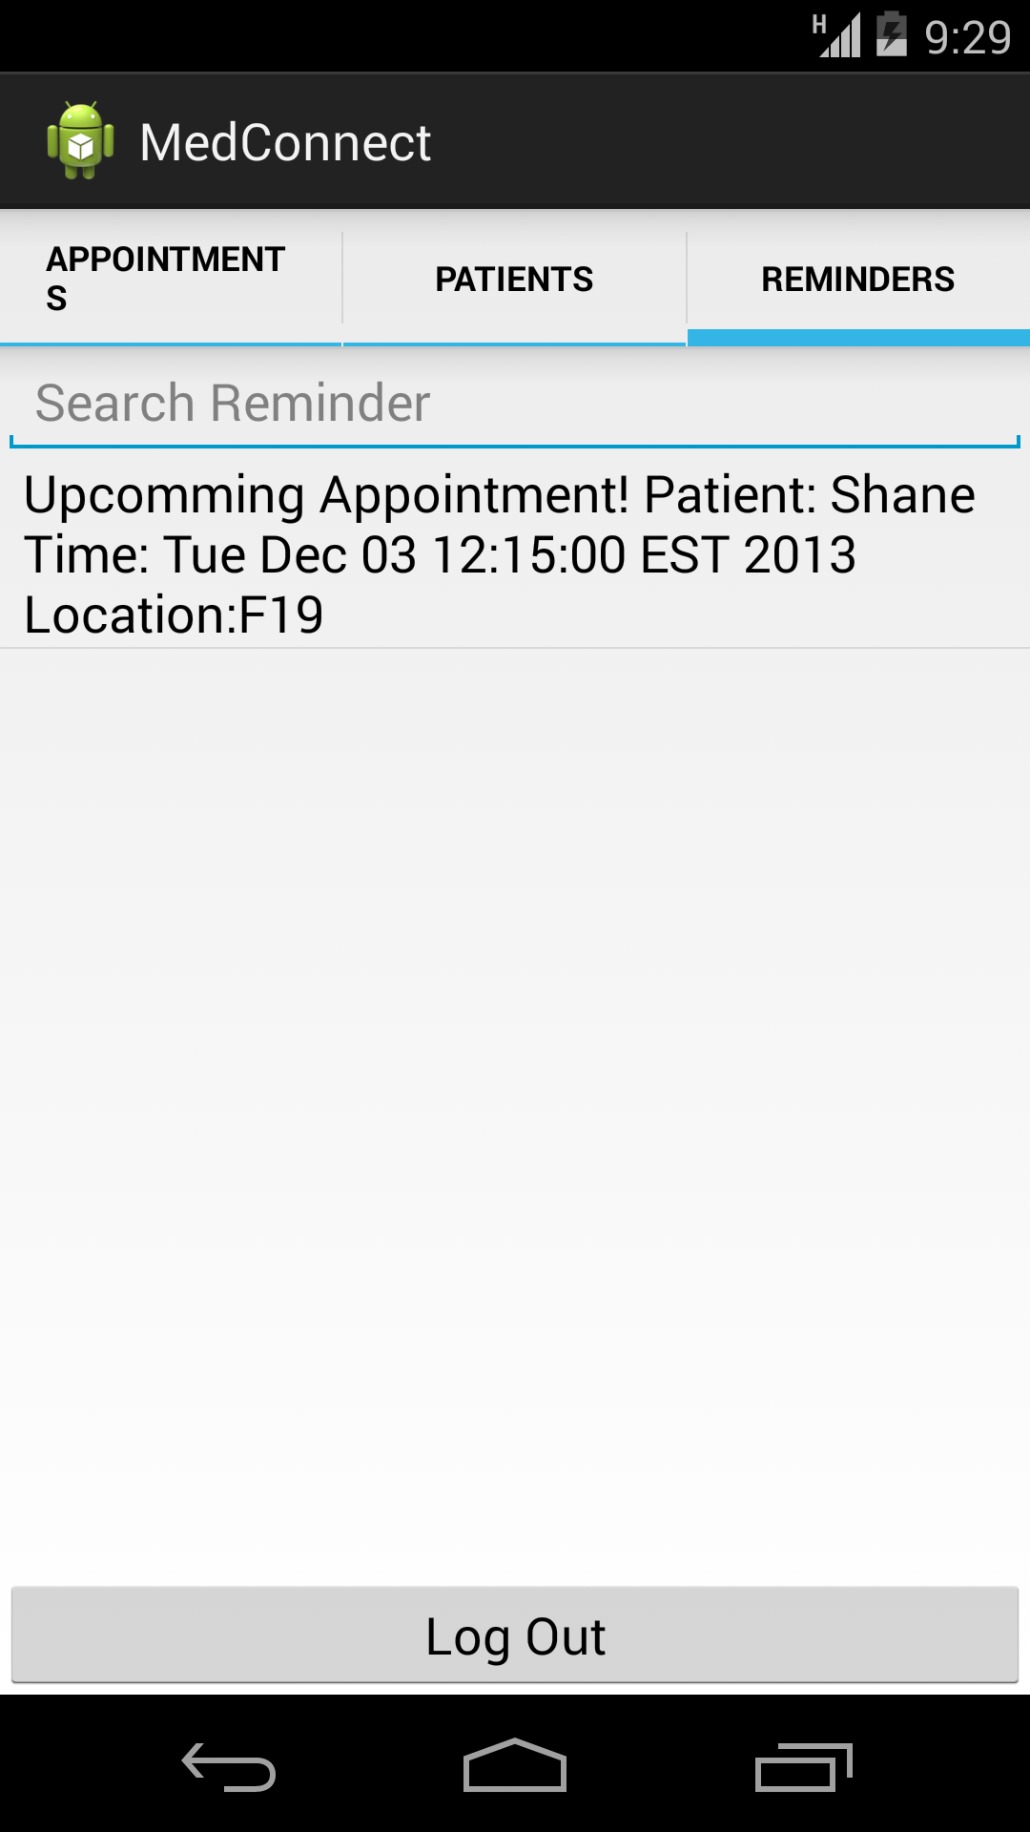

* 1. Log out of app

1. Log into app as a Nurse



* 1. View current appointments

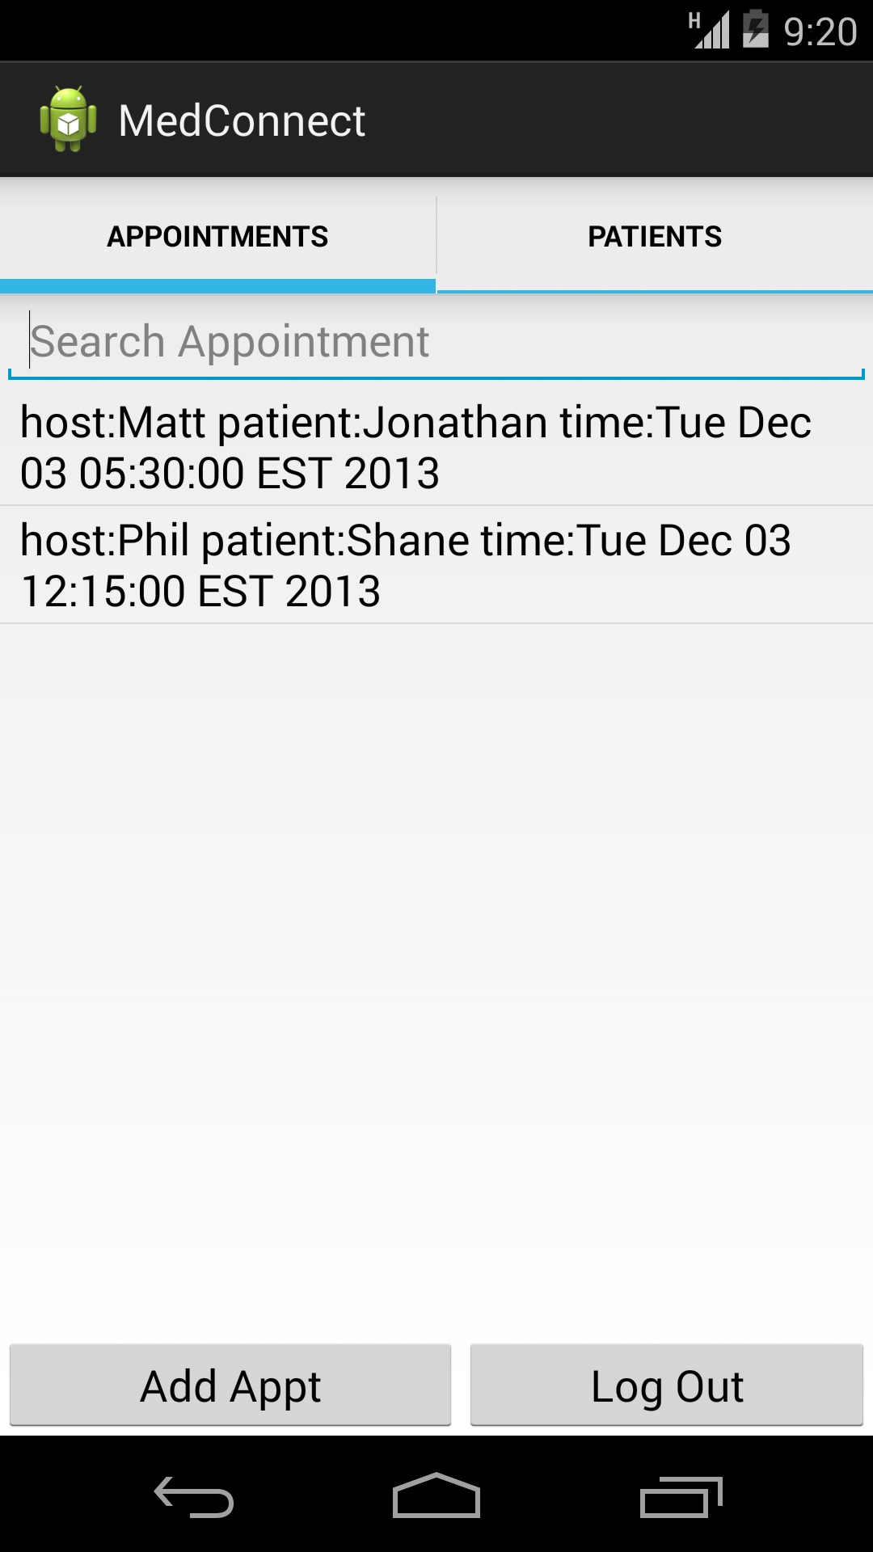

* 1. Modify a current appointment for a patient

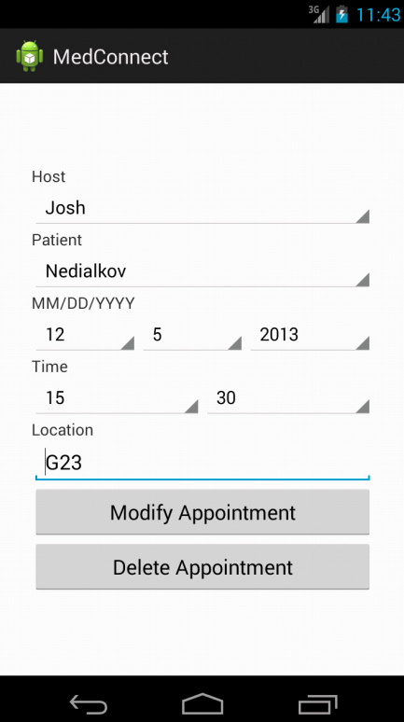

* 1. Add a new appointment to a patient

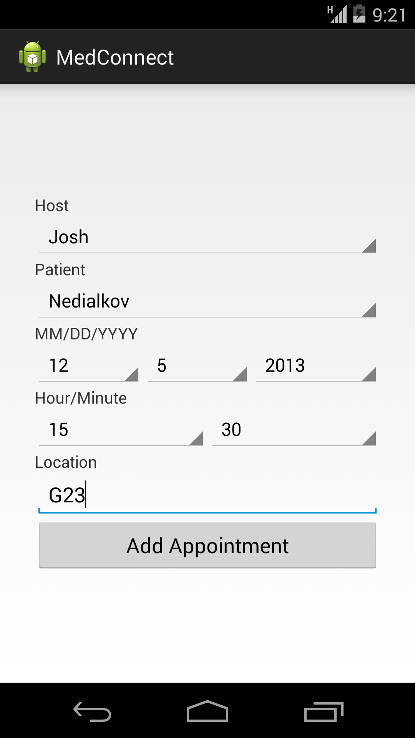

* 1. Navigate to patients tab

1. 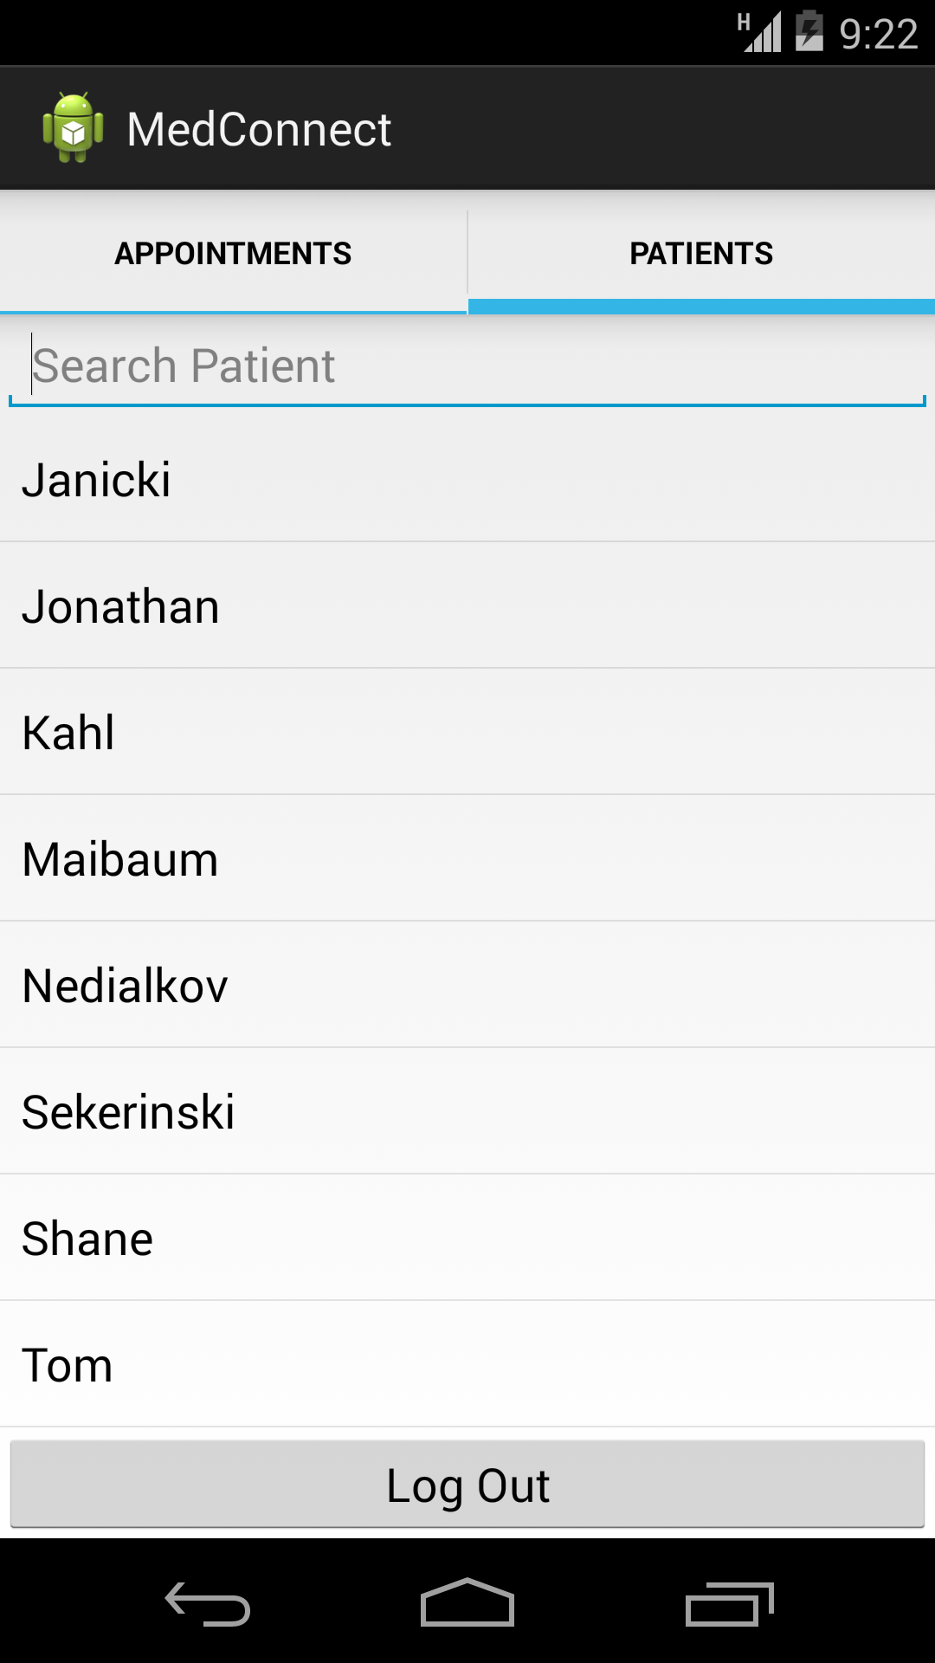
   * 1. View a patients information

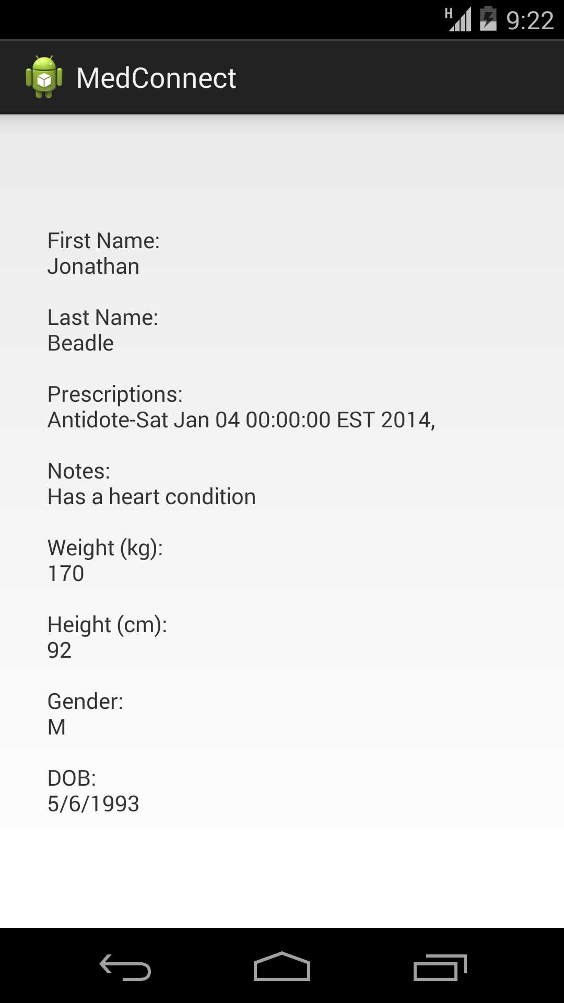

e. Log out of app

1. Log into app as a Patient



* 1. Navigate to appointments tab and view all current appointments 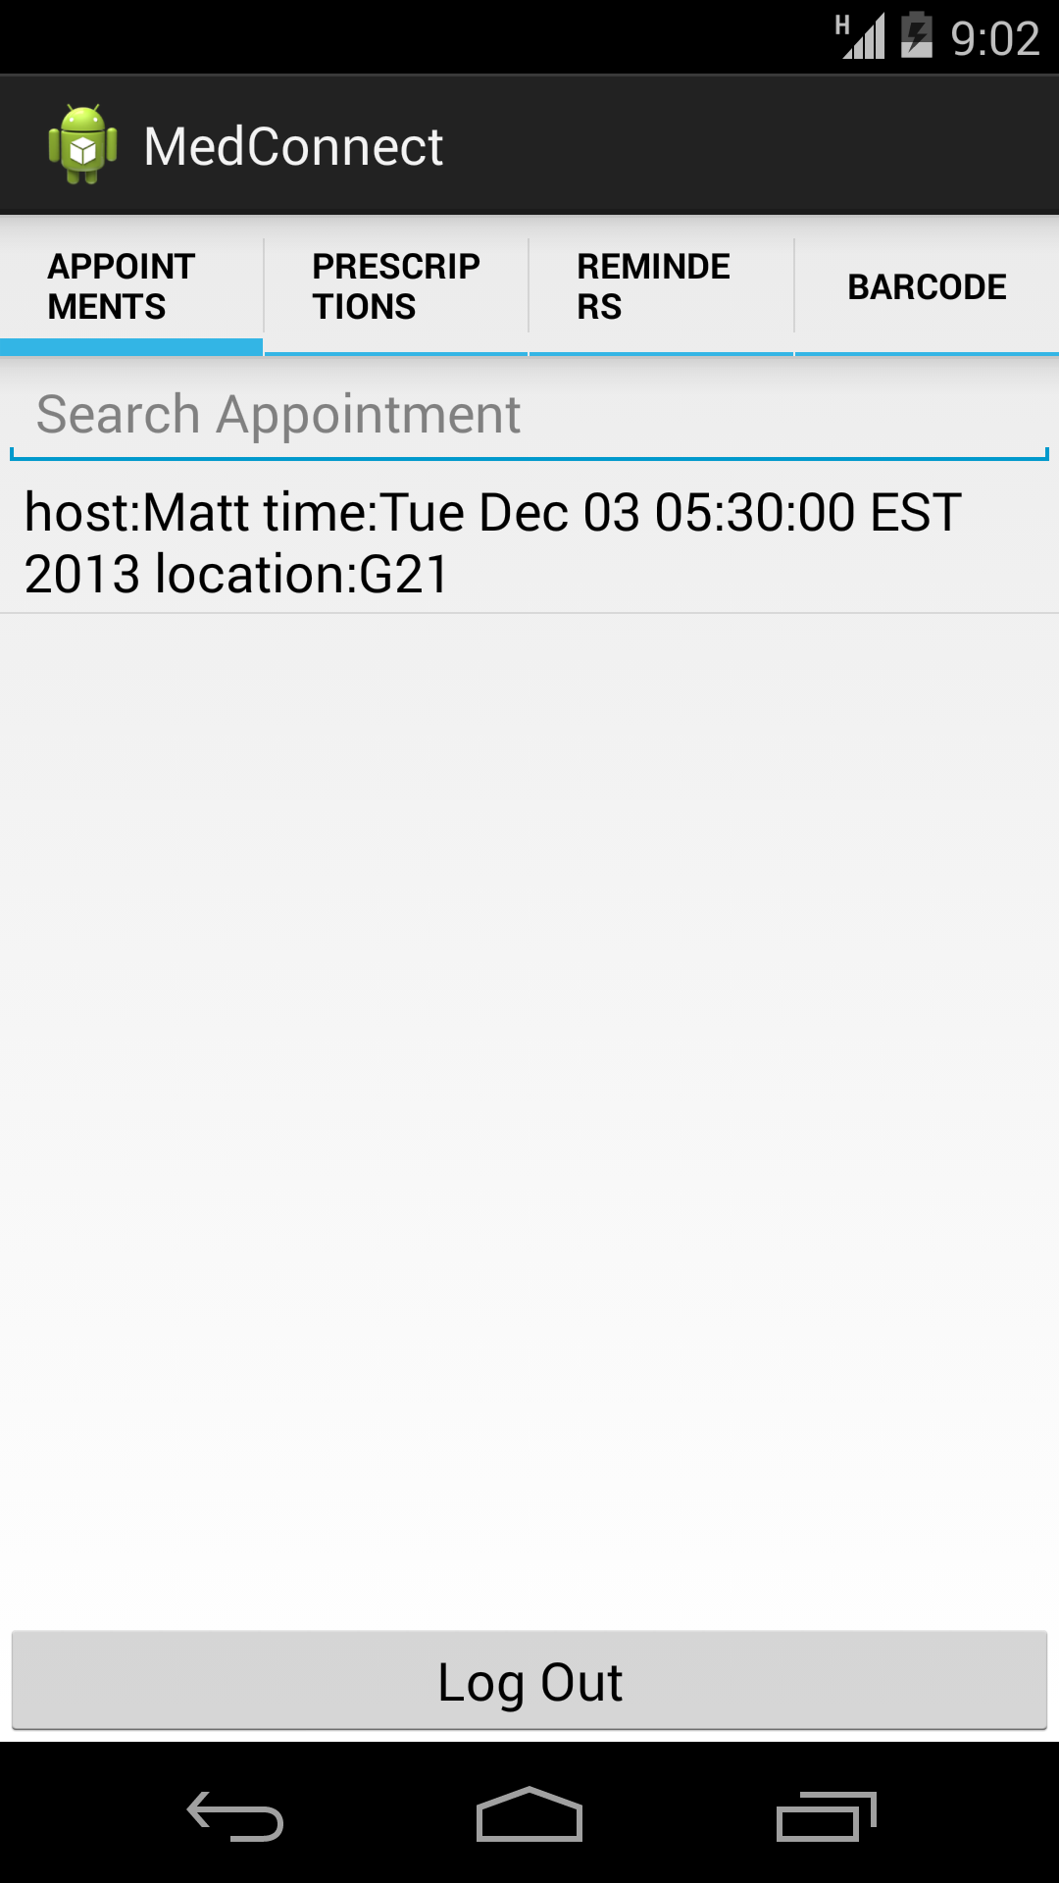
  2. Navigate to prescription tab and view all current prescriptions 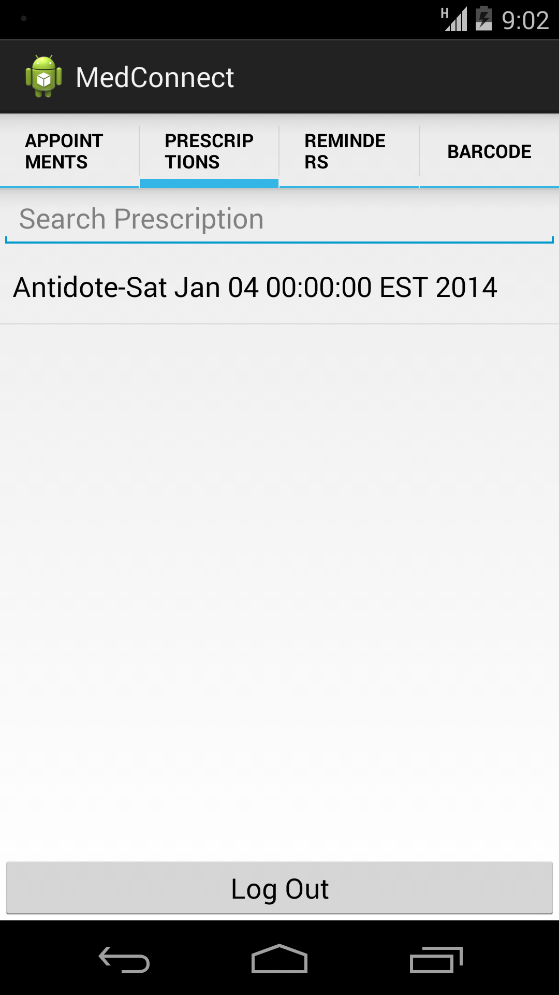
  3. Navigate to reminders tab and view all current reminders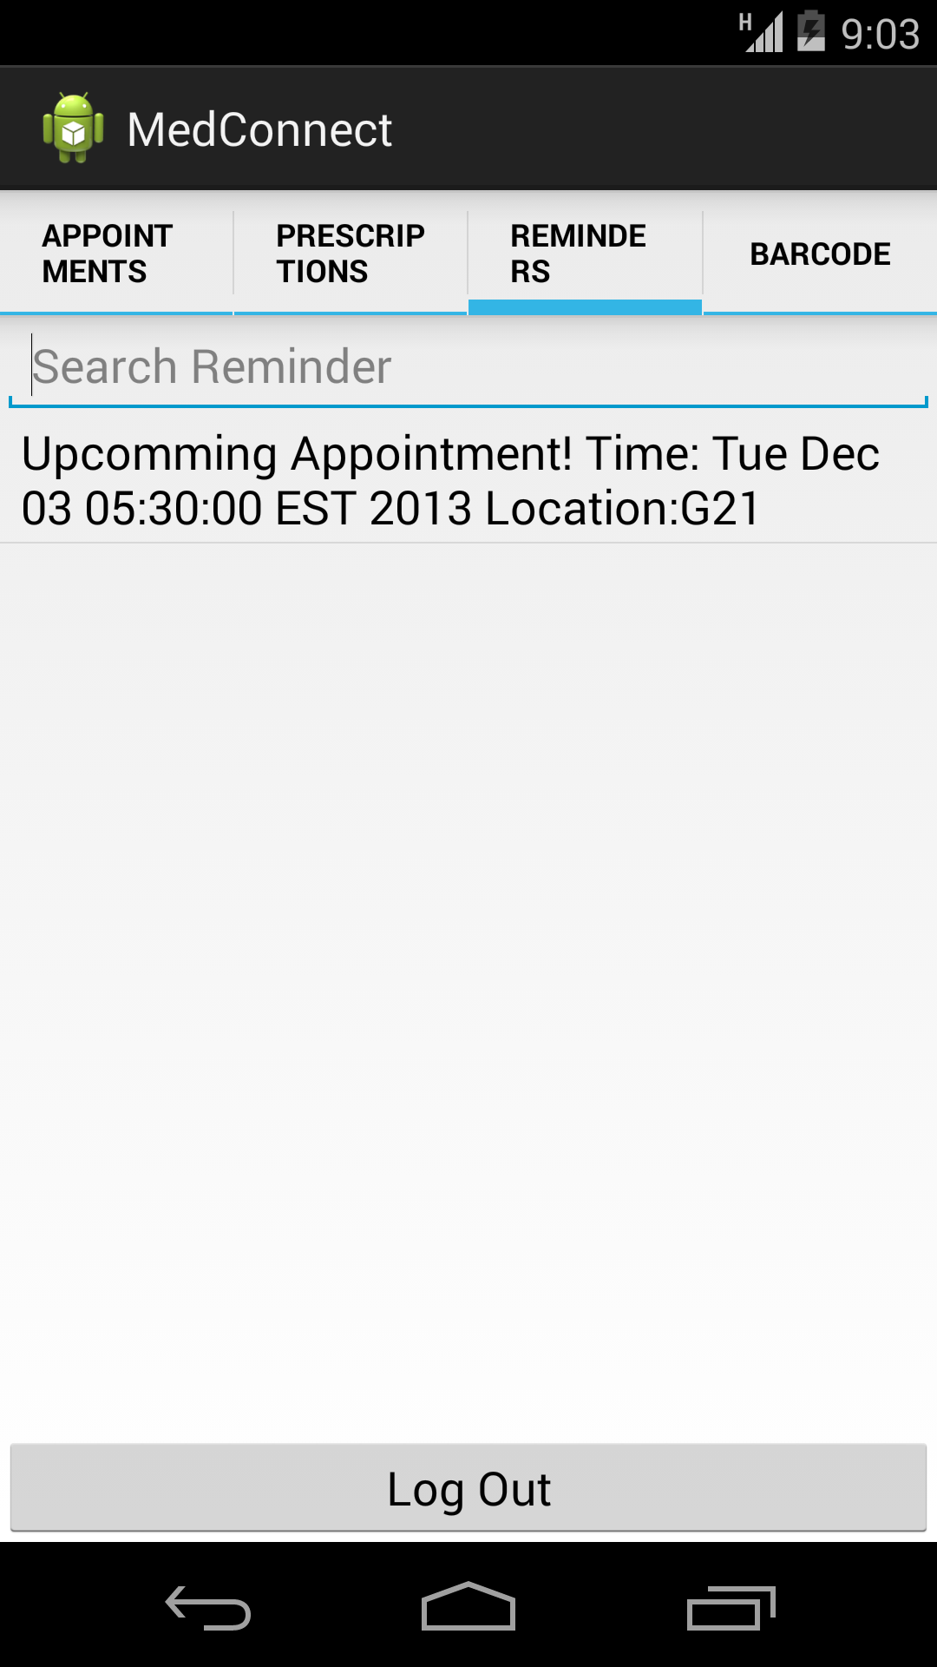
  4. Navigate to barcode tap
     1. Simultaneously have another android device with the app logged in as a doctor. Scan the barcode with the doctors device.

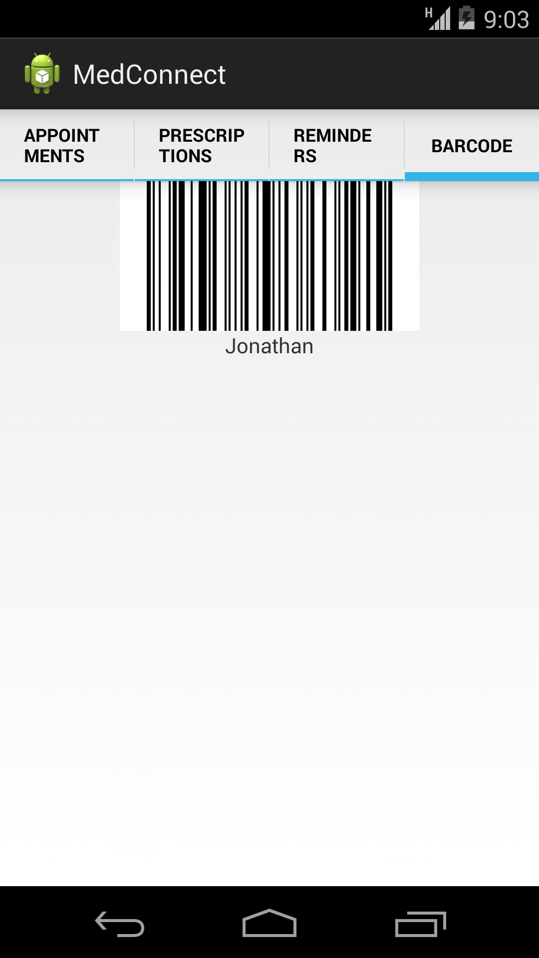

* 1. Log out of app

1. Log into app as a Nurse



* 1. Modify an appointment



* 1. Log out of app

1. Log into app as a Patient



* 1. View modified appointment



* 1. Log out of app

1. Log into app as an Admin



* 1. Modify a doctor and/or nurse (change password)

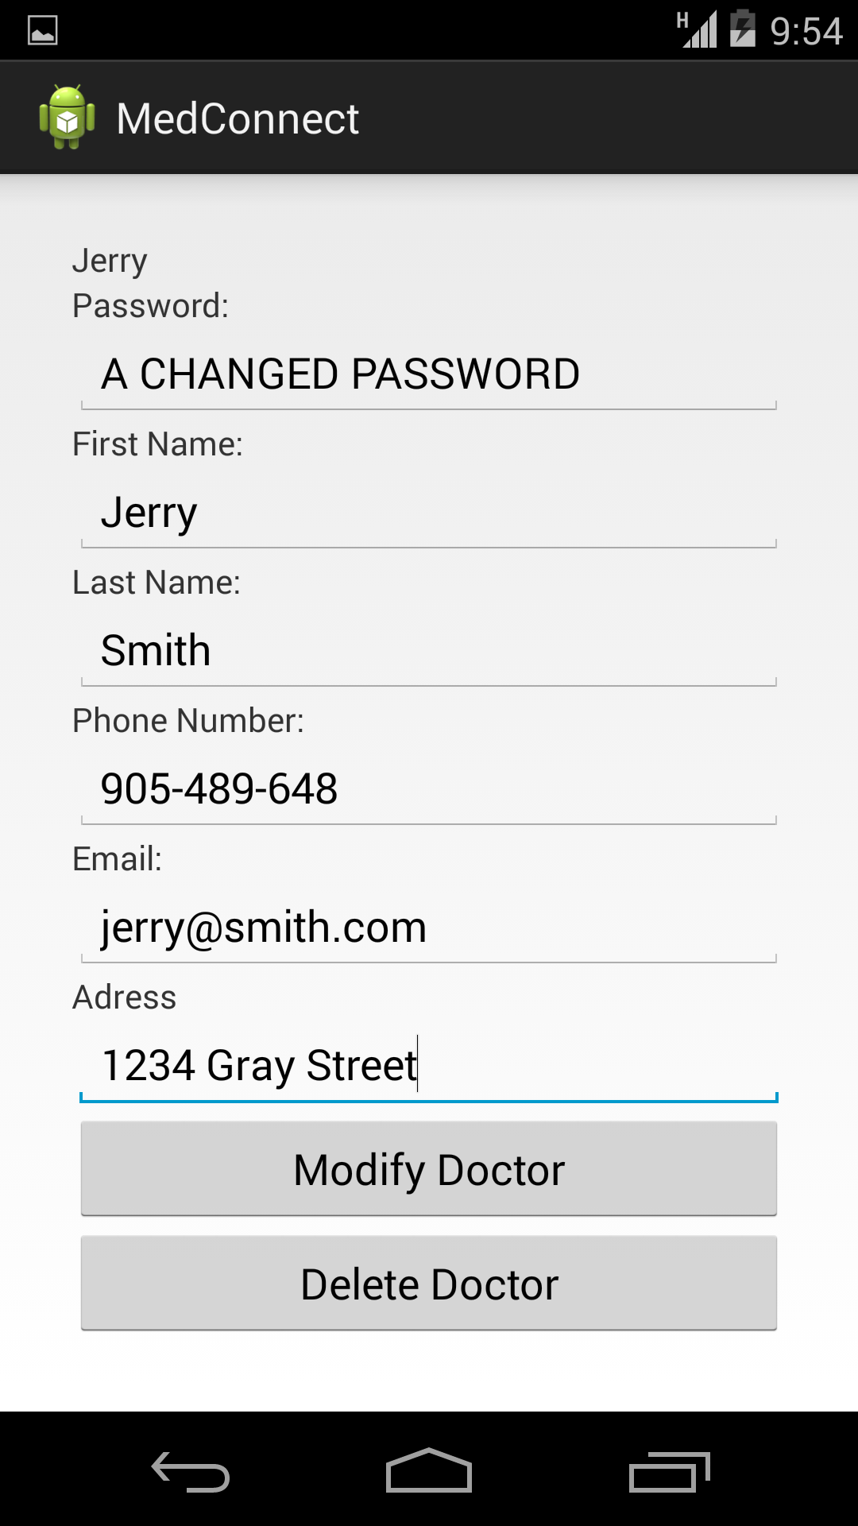

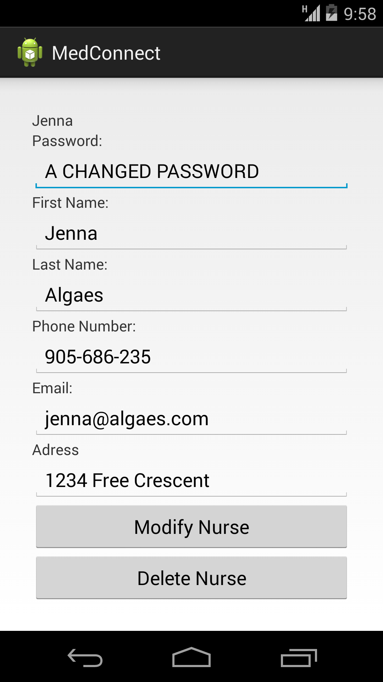

* 1. Log out of app

1. Log into app as a Doctor or Nurse (depending on which user was modified by Admin)(Attempt to login with a new password)



* 1. Log out of app.